**Lab Task 1**

**Numerical Computing Lab(105127)**

**Ali Afzal(63961)**

Q1:

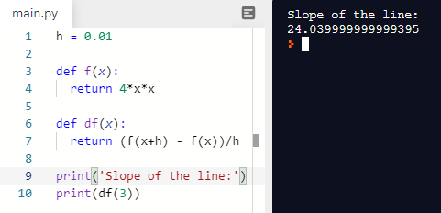

Q2:

**Transcendental Equation:**

Equations having trigonometric ratios, exponential

functions or logarithmic values are called transcendental equations.

1. import sympy as sy

sy.init_printing()

x = sy.symbols("x")

f = sy.tan(x)+12*x-2*x**2+x*sy.cos(x)

f

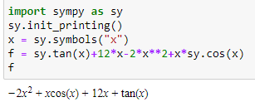

1. import sympy as sy

sy.init_printing()

x = sy.symbols("x")

f = sy.cos(x)+sy.ln(x)

f

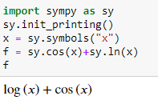

1. import sympy as sy

sy.init_printing()

x = sy.symbols("x")

f = sy.ln(x)*x**4+x-sy.cos(x)+sy.cot(x)

f

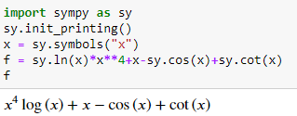

1. import sympy as sy

sy.init_printing()

x = sy.symbols("x")

f = sy.sin(x)**4+sy.sec(x)**2

f

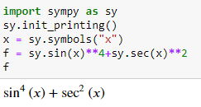

1. import sympy as sy

sy.init_printing()

x = sy.symbols("x")

f = sy.cot(x)-sy.sin(x)**4+sy.ln(x)*x**9+sy.sec(x)**2

f

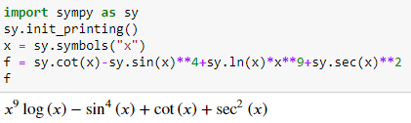

Q3:

A)

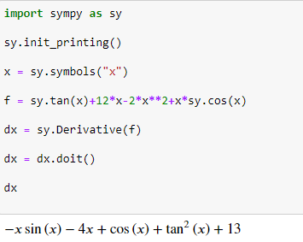

B)

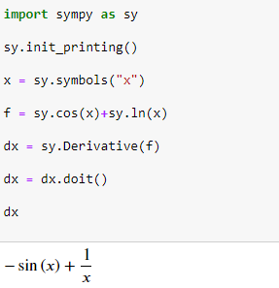

C)

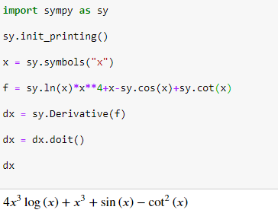

D)

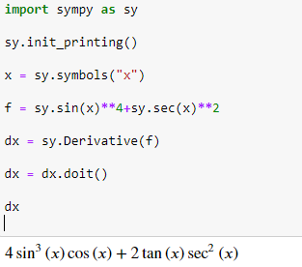

E)

